**ЛАБОРАТОРНА РОБОТА № 9**

**Варіант 2**

**Тема:** Використання графічних можливостей C#

***Мета*** : засвоїти принципи малювання графічних примітивів за допомогою .NET Framework.

**Хід роботи:**

**Завдання**:

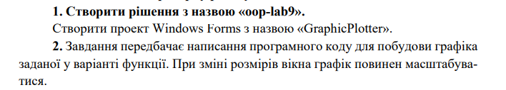



**Лістинг**:

using System;

using System.Collections.Generic;

using System.ComponentModel;

using System.Data;

using System.Drawing;

using System.Linq;

using System.Text;

using System.Threading.Tasks;

using System.Windows.Forms;

namespace GraphicPlotter

{

public partial class Form1 : Form

{

public Form1()

{

InitializeComponent();

}

private void Form1_Load(object sender, EventArgs e)

{

}

private void Form1_Paint(object sender, PaintEventArgs e)

{

one();

}

private void Form1_Resize(object sender, EventArgs e)

{

one();

}

void one()

{

Graphics g = this.CreateGraphics();

g.Clear(Color.White);

Pen a = new Pen(Color.Blue, 1);

Pen b = new Pen(Color.Green, 2);

Font drawFont = new Font("Arial", 12);

Font signatureFont = new Font("Arial", 7);

SolidBrush drawBrush = new SolidBrush(Color.Blue);

StringFormat drawFormat = new StringFormat();

drawFormat.FormatFlags = StringFormatFlags.DirectionRightToLeft;

int sizeWidth = Form1.ActiveForm.Size.Width;

int sizeHeight = Form1.ActiveForm.Size.Height;

Point center = new Point((((int)sizeWidth / 2) - 8), (int)((sizeHeight / 2) - 19));

g.DrawLine(a, 10, center.Y, center.X, center.Y);

g.DrawLine(a, center.X, center.Y, 2 * center.X - 10, center.Y);

g.DrawLine(a, center.X, 10, center.X, center.Y);

g.DrawLine(a, center.X, center.Y, center.X, 2 * center.Y - 10);

g.DrawString("X", drawFont, drawBrush, new PointF(2 * center.X - 5, center.Y + 10), drawFormat);

g.DrawString("Y", drawFont, drawBrush, new PointF(center.X + 30, 5), drawFormat);

g.DrawString("0", drawFont, drawBrush, new PointF(center.X, center.Y), drawFormat);

g.DrawLine(a, center.X + 5, 20, center.X, 10);

g.DrawLine(a, center.X - 5, 20, center.X, 10);

g.DrawLine(a, 2 * center.X - 10, center.Y, center.X * 2 - 20, center.Y - 10);

g.DrawLine(a, 2 * center.X - 10, center.Y, center.X * 2 - 20, center.Y + 10);

int stepForAxes = 25;

int lenghtShtrih = 3;

int maxValueforAxesX = 10;

int maxValueforAxesY = 10;

float oneDelenieX = (float)maxValueforAxesX / ((float)center.X /

(float)stepForAxes);

float oneDelenieY = (float)maxValueforAxesY / ((float)center.Y /

(float)stepForAxes);

for (int i = center.X, j = center.X, k = 1; i < 2 * center.X - 30; j -= stepForAxes, i += stepForAxes, k++)

{

g.DrawLine(a, i, center.Y - lenghtShtrih, i, center.Y + lenghtShtrih);

g.DrawLine(a, j, center.Y - lenghtShtrih, j, center.Y + lenghtShtrih);

if (i < 2 * center.X - 55)

{

g.DrawString((k * oneDelenieX).ToString("0.0"), signatureFont, drawBrush,

new Point(i + stepForAxes + 9, center.Y + 6), drawFormat);

g.DrawString(((k * oneDelenieX).ToString("0.0").ToString() + "-"), signatureFont, drawBrush, new Point(j - stepForAxes + 9, center.Y + 6), drawFormat);

}

}

for (int i = center.Y, j = center.Y, k = 1; i < 2 * center.Y - 30; j -= stepForAxes, i += stepForAxes, k++)

{

g.DrawLine(a, center.X - lenghtShtrih, j, center.X + lenghtShtrih, j);

g.DrawLine(a, center.X - lenghtShtrih, i, center.X + lenghtShtrih, i);

if (i < 2 * center.X - 55)

{

g.DrawString((k * oneDelenieY).ToString("0.0"), signatureFont, drawBrush,

new Point(center.X + 25, j - stepForAxes - 5), drawFormat);

g.DrawString(((k * oneDelenieY).ToString("0.0").ToString() + "-"), signatureFont, drawBrush, new Point(center.X + 25, i + stepForAxes - 5), drawFormat);

}

}

int numOfPoint = 100;

float[] first = new float[numOfPoint];

for (int i = 0; i < numOfPoint; i++)

{

first[i] = (float)maxValueforAxesX / (float)numOfPoint * (i + 1) -

(float)(maxValueforAxesX / 2);

}

float[] second = new float[numOfPoint];

for (int i = 0; i < numOfPoint; i++)

{

second[i] = (float)(Math.Pow(Math.E, first[i]/2) * Math.Sin(2 * first[i]));

}

Point[] pointOne = new Point[numOfPoint];

float tempX = 1 / oneDelenieX * stepForAxes;

float tempY = 1 / oneDelenieY * stepForAxes;

for (int i = 0; i < numOfPoint; i++)

{

pointOne[i].X = center.X + (int)(first[i] * tempX);

pointOne[i].Y = center.Y - (int)(second[i] * tempY);

chart1.Series[0].Points.AddXY(pointOne[i].X, pointOne[i].Y);

}

g.DrawCurve(b, pointOne);

}

}

}

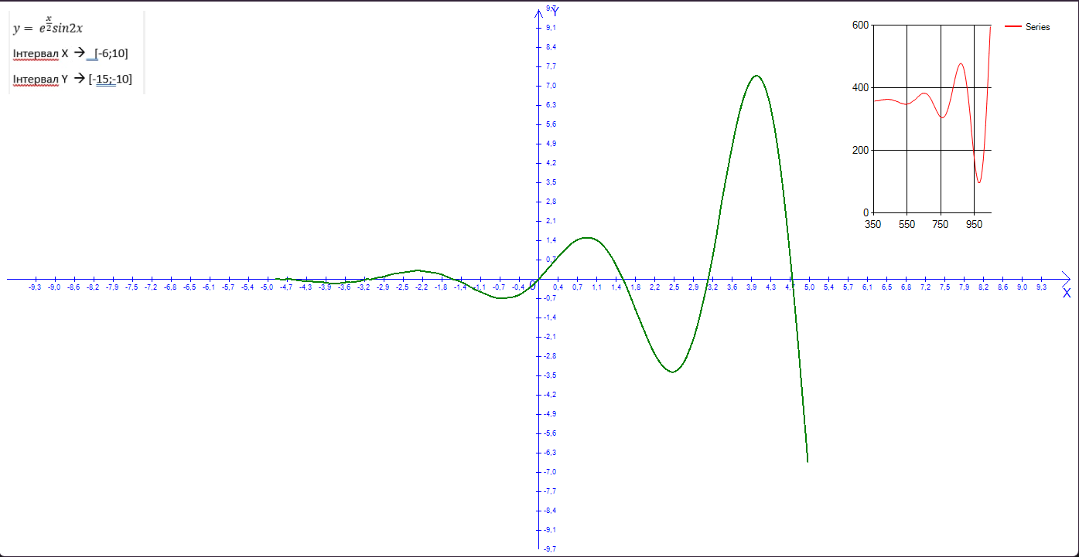

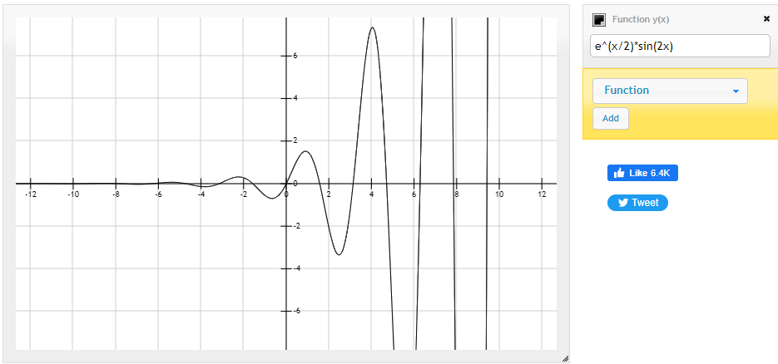

***Висновки:*** я засвоїв зпринципи малювання графічних примітивів за допомогою .NET Framework.